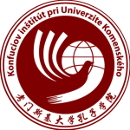
To be kept informed on actual and future activities of
the Confucius Institute at the Comenius University in Bratislava
register your details below

为能收到实时和将来的活动通知，请登记以下信息

NAME / 姓名

__________________________________________________

EMAIL ADDRESS / 电子邮箱

__________________________________________________

POSTAL ADDRESS / 邮政地址

__________________________________________________

AREAS OF INTEREST (tick all that apply)* / 感兴趣的领域（打勾）

□ Chinese Language classes /汉语课程
□ Cultural Courses /文化课程
□ Cultural Events /文化活动
□ Contemporary China/当代中
□ Volunteering /志愿服
□ OTHER / 其他

_____________________________________________________________________
_____________________________________________________________________
_____________________________________________________________________

