Traditional Chinese Calligraphy and Painting Course Outline

Teacher: Wang Baokang

Week 1:
Lesson 1: Introducing four treasures of the Chinese study, learn to use brushes, use ink, and learn the basic line drawing.

Lesson 2: Learn to paint orchids.

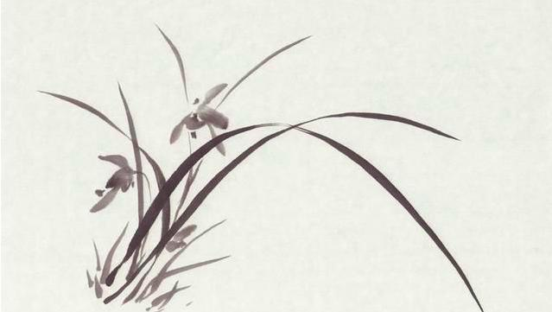

.

Week 2:

Lesson 3：Learn to paint a panda.

Lesson 4：Learn to paint bamboo.

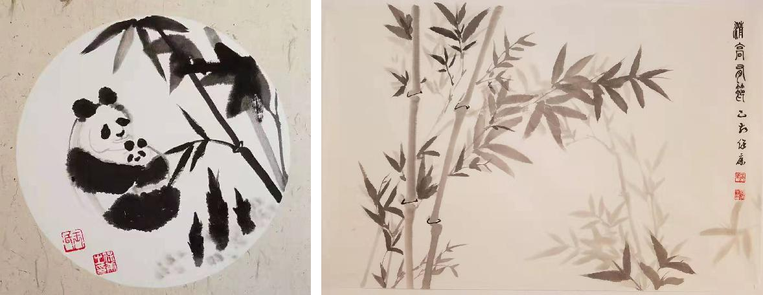

Week 3：

Lesson 5：Creating a painting with panda and bamboo.

Lesson 6：Teaching students to sign their painting in Chinese and stamp it.

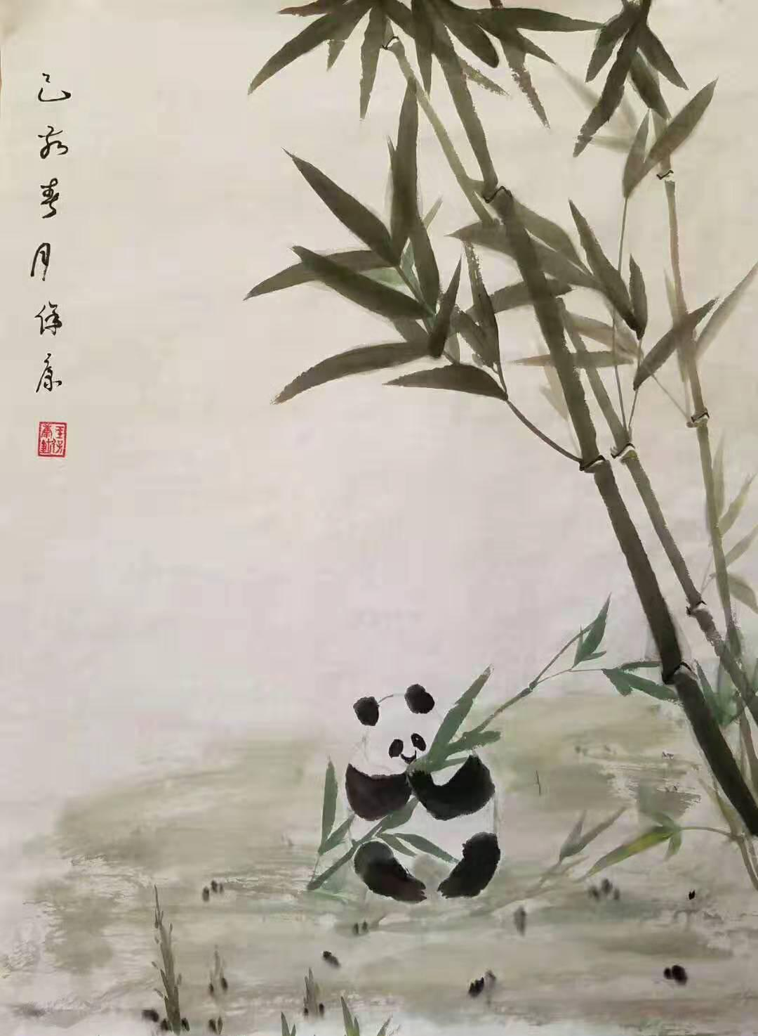

Week 4：

Lesson 7：Learn to paint hemerocallis fulva (orange day-lily) and create a painting of it.
Lesson 8：Learn to use brush to write seal characters „orange day-lily (Chinese: Xuan Cao)" and give the title to the painting from Lesson 7.

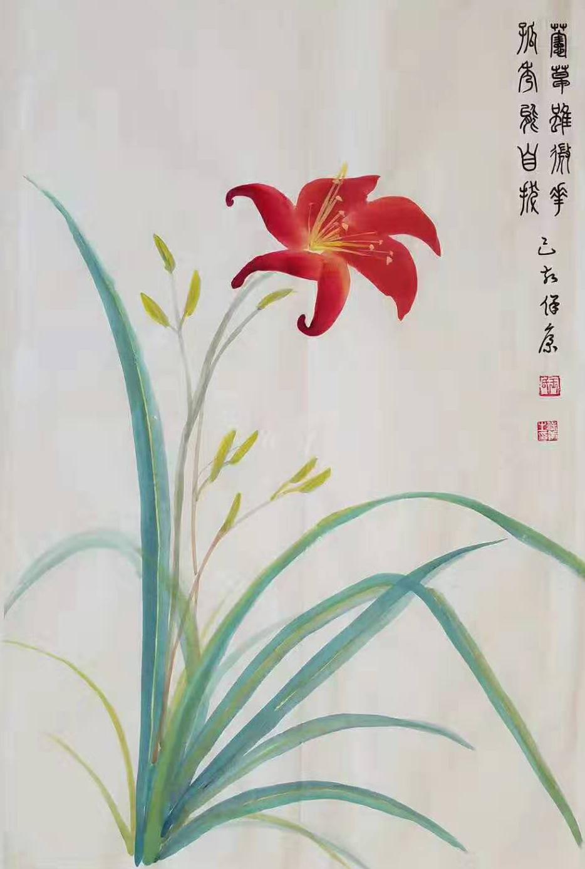

Week 5：

Lesson 9： Learn to paint a pink peony flower.

Lesson 10：Learn to paint a red peony flower.

Week 6：

Lesson 11：Learn to paint a peony bud.

Lesson 12：Learn to paint peony leaves and stems.

Week 7：

Lesson 13：Create a painting with pink peony flower, red peony flower, and a peony bud.

Lesson 14：Learn to use brush to write seal script characters „national grace, divine fragrance“ (Chinese Guo Se Tian Xiang) and give a title to the painting from Lesson 13.
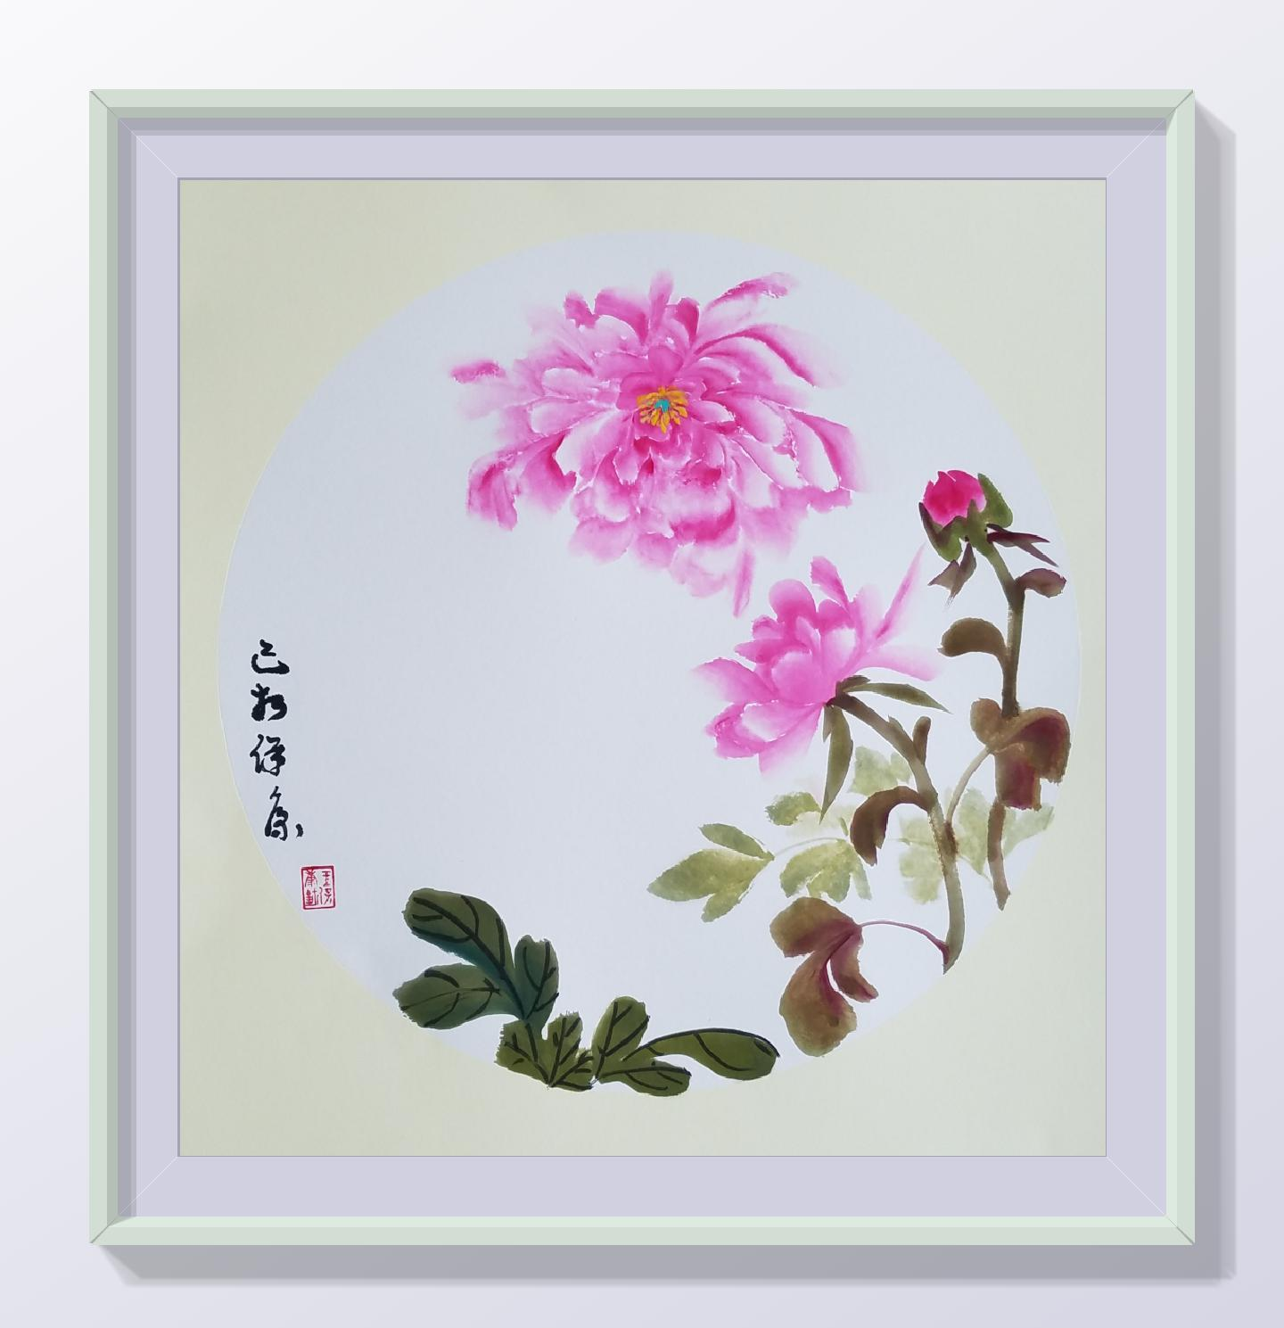

Week 8：

Lesson 15：Learn to paint a magpie.

Lesson 16：Learn to paint plum blossoms.

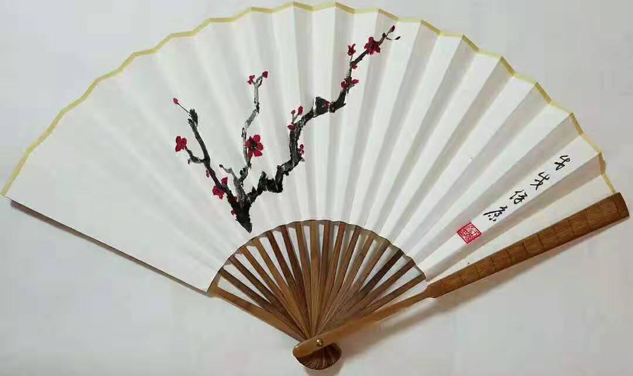

z

Week 9：

Lesson 17： Create a painting with magpie and plum blossom.

Lesson 18：Learn to use brush to write seal characters "Beaming (Chinese: Xi Shang Mei Shao)” and give the title to the work from Lesson 17.
Week 10：

Lesson 19：Learn to paint butterflies.

Lesson 20：Learn to paint orchids and create a painting with butterflies and orchids.

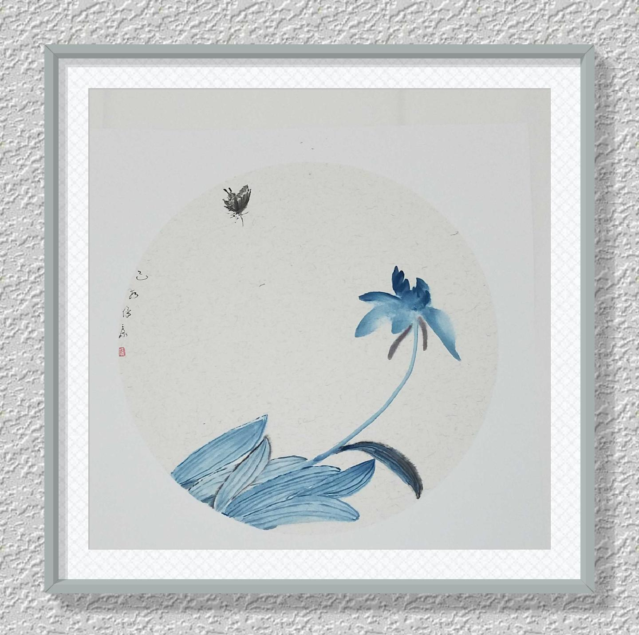

Week 11：

Lesson 21：Learn to paint wisteria.

Lesson 22：Create a painting with wisteria and butterflies.

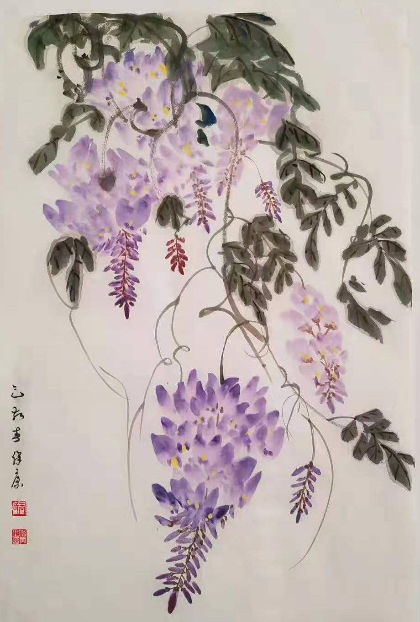

Week 12：

Lesson 23：Learn to paint a Taihu stone.

Lesson 24：Learn to paint a banana tree and create a painting including both, Taihu stone and banana tree.

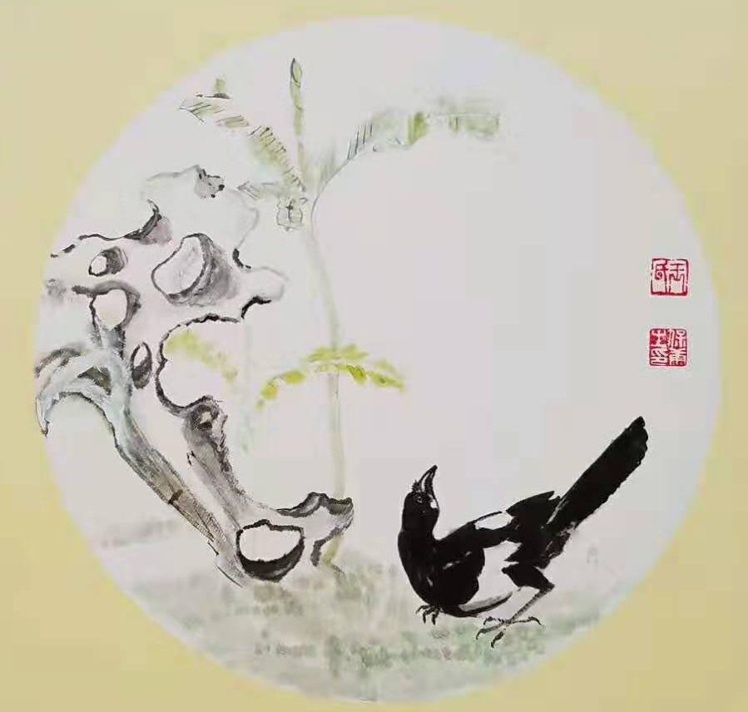

Teacher Wang Baokang’s Traditional Chinese Painting Appreciation
